Aman Patel

CSCI-B 455

February 9, 2021

Home Assignment 2

1. Neuron calculation

 $h=Σ_{i=1} w_{i}x_{i}+b= Σ_{i=0} w_{i}x_{i}$

 $h_{0,0}=0*1+0*1+1*1.5=1.5$

 $h_{1, 0}=1*1+0*1+1*1.5=2.5$

$h_{0, 1}=0*1+1*1+1*1.5=2.5$

$h_{1, 1}=1*1+1*1+1*1.5=3.5$

2. Depending on the activation function, this Perceptron could represent the AND or OR logic gate.
   3. If activation function is $y=g\left(h\right)= \left\{\begin{aligned}0, if h≤2 \\ 1, if h>2\end{aligned}\right.$
      1. $(0, 0)$ would output $0$, while the other three points would output $1$
      2. This represents the OR logic gate.
      3. 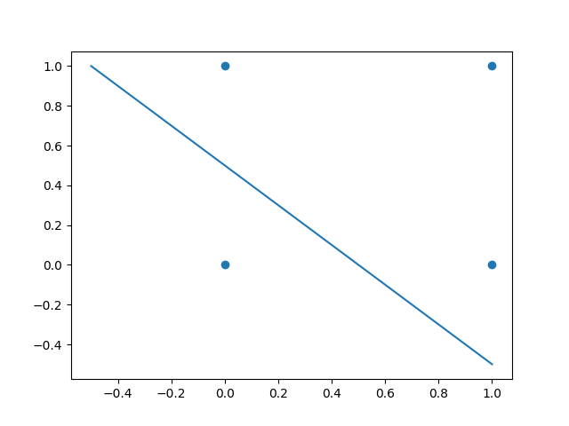Discriminant function: $y= -x+0.5$
   4. If activation function is $y=g\left(h\right)= \left\{\begin{aligned}0, if h≤3 \\ 1, if h>3\end{aligned}\right.$
      1. $(1, 1)$ would output $1$, while the other three points would output $0$
      2. This represents the AND logic gate.
      3. 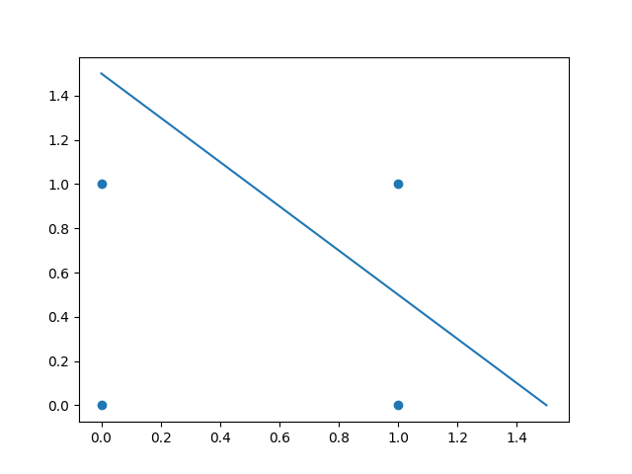Discriminant function: $y= -x+1.5$
2. A Perceptron would not be able to learn this problem for 3 inputs because there does not exist a plane that isolates the points $\left(0, 0, 0\right), \left(0, 1, 1\right), \left(1, 1, 0\right),$ and $(1, 0, 1)$ from the remaining points on the cube. As with the XOR problem, I believe this problem can also be learned by a Multi-Layer Perceptron.
3. See attached notebook.
4. Power company MLP
   1. MLP parameters
      1. This prediction can be made using a regression MLP model. The model will have one hidden layer, one output node, bias, and linear activation functions. The value of the output node will be the predicted electricity demand given data about the day.
      2. The daily demand data can be used as a target and will be used to calculate the error for back-propagation.
      3. The input parameters would be the number of customers (in thousands), day temperature, night temperature, type of precipitation (0 for none, 1 for rain, 2 for snow, etc.), and amount of precipitation for each day (# inches). Average customer income can also be incorporated if there have been significant income fluctuations.
      4. All data would be normalized to improve calculations.
   2. The weather forecast for the next day would be important as an input to predict the upcoming demand. The temperature and precipitation are the most volatile factors but will be the most useful for making demand predictions.
   3. I believe this system would work well for predicting the average demand for a long stretch, but it would have difficulty with short-term predictions. For example, the model may be able to predict the average demand for a winter week, but it would not be able to predict the demand correctly on Christmas Day, as the demand is unusually low due to business closures.
5. Hospital MLP
   1. This is another example of a regression problem where the user wants to predict a specific value as opposed to a classification problem, where the user wants to predict the class of an input.
   2. Inputs: the weather, the season, if an epidemic was on, elderly population data, number of nurses, number of doctors
   3. Output: predicted number of beds needed
   4. Inputs will be normalized, shuffled, and assigned to training, testing, and validation groups.
   5. The model will have one hidden layer with 3 nodes. This will compress the data and increase the speed of training. The output layer will have one node whose value is the predicted number of beds needed.
   6. The model will be trained using a back-propagation algorithm, validating the model before overfitting occurs. As this is a regression problem, the ReLU activation function will be used. ReLU is useful because the predicted value will never be negative.
   7. I believe the model would be able to give an accurate estimation of the number of beds needed for average days. However, the number of beds can vary significantly from day-to-day, and the model may be error-prone as a result.